Software Design Document for

GradeUP
Version 1.0
Prepared by
Akash Ravi | Nikhil Tiware | Parikshit Tiwari
Shashank Sharma | Shruti Nafday | Shweta Amla

A-Team
September 10, 2015

Table of Contents

Name of Product 1
1.0 Introduction 5
1.1 Goals and objectives 5
1.2 Statement of scope 5
1.3 Software context 5
1.4 Major constraints 5
2.0 Data design 6
2.1 Internal software data structure 6
2.2 Global data structure 6
2.3 Temporary data structure 6
2.4 Database description 6
3.0 Architectural and component-level design 7
3.1 System Structure 7
3.1.1 Architecture diagram 7
3.2 Description for Component “n” 7
3.2.1 Processing narrative (PSPEC) for component “n” 7
3.2.2 Component “n” interface description. 7
3.2.3 Component “n” processing detail 7
3.2.3.1 Design Class hierarchy for component n 8
3.2.3.2 Restrictions/limitations for component n 8
3.2.3.3 Performance issues for component n 8
3.2.3.4 Design constraints for component n 8
3.2.3.5 Processing detail for each operation of component n 8
3.2.3.5.1 Processing narrative (PSPEC) for each operation 8
3.2.3.5.2 Algorithmic model (e.g., PDL) for each operation 8
3.3 Dynamic Behavior for Component n 8
3.3.1 Interaction Diagrams 8
4.0 User interface design 9
4.1 Description of the user interface 9
4.1.1 Screen images 9
4.1.2 Objects and actions 9
4.2 Interface design rules 9
4.3 Components available 9
4.4 UIDS description 9
5.0 Restrictions, limitations, and constraints 10
6.0 Testing Issues 11
6.1 Classes of tests 11
6.2 Expected software response 11
6.3 Performance bounds 11
6.4 Identification of critical components 11
7.0 Appendices 12
7.1 Requirements traceability matrix 12
A matrix that traces stated components and data structures to software requirements is developed. 12
7.2 Packaging and installation issues 12
7.3 Design metrics to be used 12
7.4 Supplementary information (as required) 12

Revision History
Name | Date | Reason For Changes | Version

You should begin to develop the software design specification after completion of the software requirements specification. The software requirements feed the design task.
At this point, your team should decide on a programming language for the project. If you are new to the language, take time to become familiar with it, before you proceed.
The software design specification focuses on how the system will be constructed. It includes four models: data design , architectural design , interface design and component-level design.
Before you begin, please study chapters 11-16 in the text.
Your document should follow the template below. It is a modified version of the Pressman's Adaptable Process Model template for a software design document.
(Section 1.0 is repeated from the Software Requirements Specification. This section provides background information about the SW.)

1.0 Introduction
The purpose of this document is to provide an insight into the design aspects of the GradeUP application. The topics covered in this document are:
- Architectural Design
- Database implementation
- User interface design
- Class hierarchies
- Design Constraints
- Test Cases
This document is intended for both the stakeholders and the developers of the system.

1.1 Goals and objectives
Overall goals and software objectives are described.
The GradeUP android application is being designed to ease the user’s effort in studies. The intended users for this application are students who need guidance on any sought of study topics but are not well verse with networking and sharing knowledge at an open platform. The application explores few of the networking possibilities by connecting one student to other students with some level of expertise through open discussion forums, group discussions and by organizing small group meetings seamlessly.

1.2 Statement of scope
It is targeted for anyone who wants to collaborate & share knowledge efficiently by the means of study groups but are facing scheduling problems due to conflicting timetables. The application helps all users in a group find a common time slot during which they are all free to meet for study. It helps the user in finding friends who are free to help with the specific subjects and form study groups to simplify the process of studying. It also aims at providing a forum for general subject related discussions. The application can be used to effectively manage the group meetings. This will reduce the effort required in getting help for completing a course or subject and would ideally help improve the grade of a student who uses it or make it easy for anyone trying to learn any subject. It will help the user finish their coursework in an organized manner. Thus, the application has universal scope and can be used by anyone. The long term vision is to make everyone’s student life easier and help them get organized.

A description of the software is presented. Major inputs, processing functionality and outputs are described without regards to implementation detail. Rank the major processing functionality from the developer's point of view. Use a simple ranking system such as: essential, desirable and future requirements. This should represent what you think your team can accomplish in the time frame of a semester. The essential requirements, you are sure you can complete. The desirable requirements you hope to complete, but are not sure about. The future requirements, you have strong doubts about. Strive to balance the desires of your client with the reality of the time it takes to develop a SW product.

1.3 Software context
The software is developed as a project, which is part of the Computer Science Graduate level coursework. This app will be made public for no extra cost through the android play store. No commercial release of this software for business purposes is intended as of now.
The software is placed in a business or product line context. Strategic issues relevant to context are discussed. The intent is for the reader to understand the 'big picture'.

1.4 Major constraints
Due to lack of experience of team members with android development environment, the learning curve will be steep. Thus the team members will need to learn the new technology as well as progress with the app development in a limited timeframe. As a consequence, the delivery of certain application features may be delayed due to a hard deadline. This might result in a reduced number of features being delivered, with the core features untouched.
Any business or product line constraints that will impact the manner in which the software is to be specified, designed, implemented or tested are noted here.

2.0 Data design
This is a description of all data structures including internal, global, and temporary data structures.

2.1 Internal software data structure
Data structures that are passed among components of the software are described.

2.2 Global data structure
Data structures that are available to major portions of the architecture are described.

2.3 Temporary data structure
Files created for interim use are described.

2.4 Database description
This section gives an insight into the database structure being used in the application project and elaborates on the different parts of the ERD, known as Entity-Relationship Diagram, which is a visual representation of the relationship between various database entities.

Database(s) created as part of the application is (are) described. (Provide enough detail to create the database.)

2.4.1 Database System
The GradeUP application will be using SQLite database for storing all the application and user data. SQLite is an in-process library that implements a self-contained, transactional SQL database engine with the biggest advantage of having an open source code. Apart from this, SQLite is a Relational Database Management System and thus makes a good platform for learning SQL which will stand beneficial for the development team.

2.4.2 Entity-Relationship Diagram

3.0 Architectural and component-level design
A detailed description of the program architecture is presented here.

3.1 System Structure
The GradeUP application system structure is based on MVC design structure. MVC stands for Model-View-Controller. Essentially, it separates the application data structure, code logic and interfaces design from one another. The main advantage being that any minor changes in one of the three does not affect the other two.
A detailed description the system structure chosen for the application is presented.

3.1.1 Architecture diagram
A diagrammatic representation, using a UML component diagram, of the MVC architecture is presented.

3.2 Description for Component “n”
Description of MVC components
A detailed description of each software component contained within the architecture is presented. Section 3.2 is repeated for each of n components.

3.2.1 Processing narrative (PSPEC) for component “n”
A processing narrative for component n is presented. It should describe the responsibilities of the component.

3.2.2 Component “n” interface description.
A detailed description of the input and output interfaces for the component is presented.

3.2.3 Component “n” processing detail
A detailed algorithmic description for each component is presented.

3.2.3.1 Design Class hierarchy for component n

3.2.3.2 Restrictions/limitations for component n

3.2.3.3 Performance issues for component n

3.2.3.4 Design constraints for component n

3.2.3.5 Processing detail for each operation of component n

3.2.3.5.1 Processing narrative (PSPEC) for each operation

3.2.3.5.2 Algorithmic model (e.g., PDL) for each operation

3.3 Dynamic Behavior for Component n
A description of the interaction of the classes is presented.

3.3.1 Interaction Diagrams
A sequence diagram, for each use case the component realizes, is presented.

4.0 User interface design

The user interface of the GradeUP application consists of a series of menus and screens which will make the use of the application simple and intuitive. The screens are as follows. The “Login” screen, “Registration” screen, “User Dashboard” screen, “Sidebar” menu, “Add Schedule” screen, “Create Group” screen, “Group Homepage” screen, “Join Group” screen, “Schedule Meeting” screen and “Discussion Forum” 4.1 Description of the user interface
A detailed description of user interface including screen images or prototype is presented.

4.1.1 Screen images
The following section describes the various screen the user will see and the action he/she will be able to perform
LOGIN PAGE
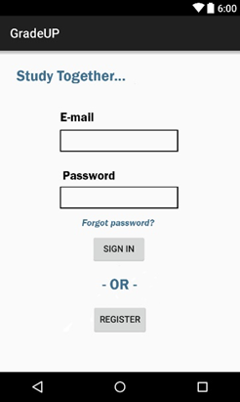
- The first screen the user will see when entering the application will be the Login Page. In here first time user will have to register themselves in to the application by clicking on the “Register” button. This will redirect the users to the “Registration” screen.

- Returning users will have to enter their Email Id and password in the textboxes provided and then click on ‘Sign In” button. If the email id and password combination is correct the user will be redirected to User DashBoard screen

- If the user does not enter the valid Email Id and password combination a error message saying “Please enter correct Email Id or Password”

REGISTRATION

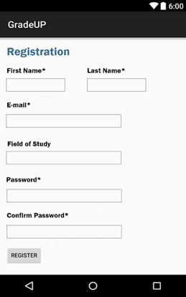

- A first time user has to be registered and will be redirected to a registration page where the user will be asked to enter his/her first name, last name, field of study, a password and confirm password.
- If the user enters an incorrect email id then an error message saying “Enter a valid Email Id”
- The user will not be allowed to register if the Email ID is invalid and if the Password and Confirm Password does not match
- If the information is validated the user will click REGISTER and be redirected to the “User Dashboard” screen

USER DASHBOARD

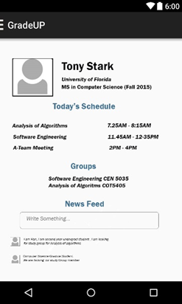

- On the dashboard the user will be able to see his/her schedule the groups the user is a part of and the news feed.
- The user will be able to navigate to his/her groups list by clicking on the Groups button

SIDEBAR
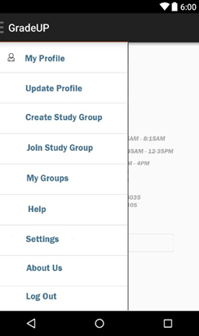

- The Sidebar is a menu which the user can see from any page by swiping to the right, from this menu the user can navigate to the “My Profile”, “Update Profile”, “Create Study Group”, “Join Study”, “My Groups”, “Help”, “Settings”, “About Us” and “Logout”
- The user will be able navigate to any of these pages by clicking on them.
ADD SCHEDULE
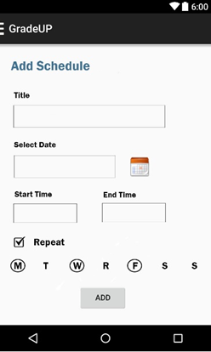

- On the “Add Schedule” screen the user will be able to enter his/her schedule. The page allows the time slot to be given a title. A date field will allow the user select a date.
- The user will click on the Start Time and End Time dropdown to select his time slot. The dropdown will contain time on the 24 hour format in half hour intervals.

CREATE GROUP
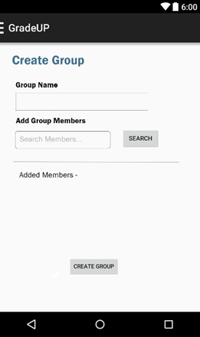

- On the Create Group page the user will be able to create a page. In the group name field the user will be asked to enter a unique group name. A message saying please enter a unique group name will be shown
- The user can also add other users to the group using the email id to search.
- The group will be created on click of the CREATE GROUP, when at least one other user other than the creator is added to the group and if the group has a unique name.

JOIN GROUP
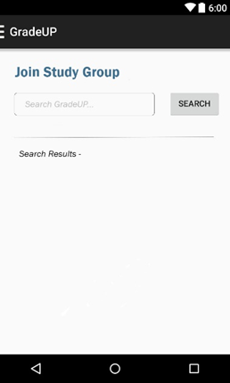
- On the Join Group page the user will enter group names and click search. The search results will be returned in a list. The user will then click on the group name and be redirected to the Group Homepage.

GROUP HOMEPAGE
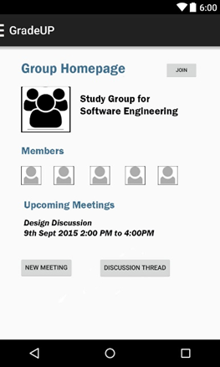

- On the group homepage the user will be able to see the members present in the group, the group schedules and upcoming meetings.
- The user can join the group by clicking the JOIN button. On click of the JOIN button a request is sent to the Admin of the group, who approves or denies the request.
- Once a member joins the group, the user will be able to see the NEW MEETING and DISCUSSION THREADS buttons. The new meeting button will allow the user to create a new meeting based on the free time shown in the GROUP SCHEDULE page
- On click of the DISCUSSION THREAD the user will be redirected to the DISCUSSION PAGE.

4.2 Interface design rules
Conventions and standards used for designing/implementing the user interface are stated. (You could list the eight golden rules mentioned in lecture.)
The interface design rules for GradeUP are derived from the following Rules of Interface Design, some of them being derived from Ben Shneiderman’s “Eight Golden rules of Interface design”. Here’s a description of each rule, as well as how the rule applies to GradeUP.

- Strive for consistency.
Consistent sequences of actions should be required in similar situations. Identical terminology should be used in prompts, menus, and help screens, and consistent commands should be employed throughout. For each screen in GradeUP: all of the major options are displayed in the sidebar menu such as My Profile, Update Profile, Create/Join Study Group(s), Logout etc..

4.3 Components available
GUI components available for implementation are noted.

4.4 UIDS description
The user interface development system is described. (You might not have one for your project.)

5.0 Restrictions, limitations, and constraints
Special design issues which impact the design or implementation of the software are noted here.

6.0 Testing Issues
Test strategy and preliminary test case specification are presented in this section.

6.1 Classes of tests
The types of tests to be conducted are specified, including as much detail as is possible at this stage. Emphasis here is on black-box and white-box testing.

6.2 Expected software response
The expected results from testing are specified.

6.3 Performance bounds
Special performance requirements are specified.

6.4 Identification of critical components
Those components that are critical and demand particular attention during testing are identified.

7.0 Appendices
Presents information that supplements the design specification.

7.1 Requirements traceability matrix

A matrix that traces stated components and data structures to software requirements is developed.

7.2 Packaging and installation issues
Special considerations for software packaging and installation are presented.

7.3 Design metrics to be used
A description of all design metrics to be used during the design activity is noted here.

7.4 Supplementary information (as required)

